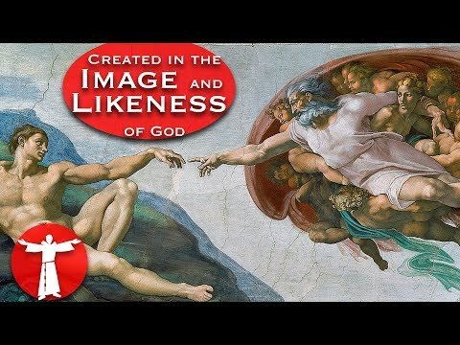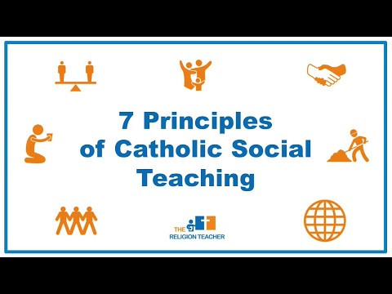

Elective Option C: Living as Disciples of Jesus in Society
Foundations of Catholic Social Teaching
Video Title and Description | URL Video Link
1. Seven Principles of Catholic  Social Teaching  This short video provides an excellent introduction the seven principles of Catholic social teaching by giving examples of how they relate to our society today. | https://youtu.be/HU8b0E-  SPtw?list=PLzpyD8yiodjGcJw8_X-  SfNZj_58gDsoqX
2. The Natural Family  Foundation for Social Justice  This video covers family strength and family cohesion as a foundation for social justice. Children have a right to have a stable, loving and natural family structure. The poverty of not having a mother or father is discussed. | https://youtu.be/j9AKNwHRJHk
3. Created in the Image and  Likeness of God  What does it mean to say we are created in the Image and likeness of God? This video discusses the meaning and implications of this foundational teaching. | https://youtu.be/lwBI-hk8-  hI?list=PLIEHvf1_M4UuA0RA03q6AIQf7oxbbEzIK

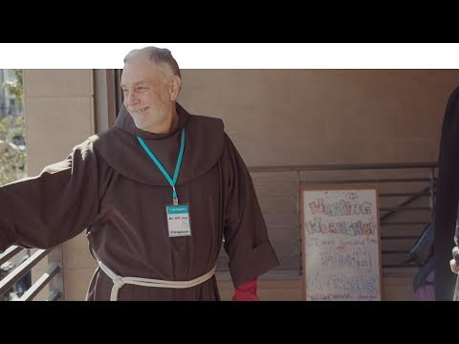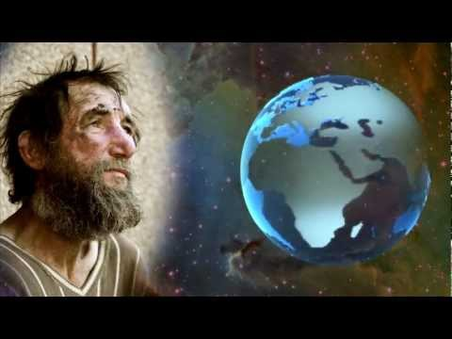
4. Why Catholic Care about the  Poor  By emphasizing the preferential option for the poor, this video introduces the sense of duty that Catholics have to advocate and serve the poor in our own communities. Pope Benedict XVI is featured as an advocate of Catholic social teaching. | https://youtu.be/yFR3rboMsh0
5. Service to the Poor: A Friar  Life  In San Francisco, the St. Anthony Foundation thousands of people per day in various ways. Behind the foundation are chaplains like Br. Dick "DT" Tandy, OFM who are profiled in this video, offering spiritual support  to all in need. | https://youtu.be/-  YB8qcO2RVQ?list=PLIEHvf1_M4UuvOI3qh6DE_BfkuXlKqckG
6. Food Waste a Story of  Excess  In this thought provoking mini- documentary, the facts and statistics of everyday food waste are exposed. This video serves as a reminder that we have an obligation to feed the hungry. | https://youtu.be/EwVuz0UJl2A
7. Pope Francis on the  Throwaway Culture  This is an introduction to one of  Pope Francis’ themes for the sanctity of life. It features his call to reverse what he calls the “throw away culture.” Not only does materialism produce an indifference to things but | https://youtu.be/IyGSpdrIT60

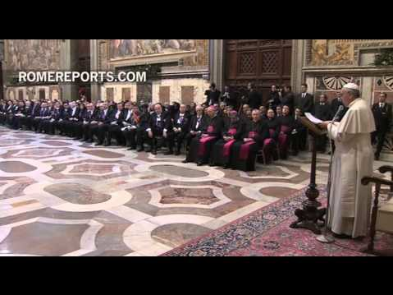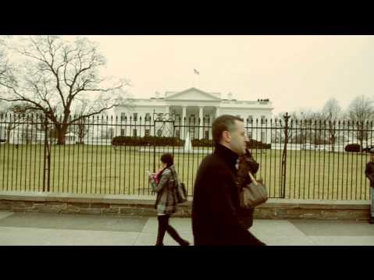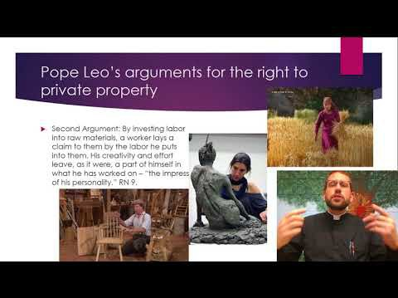
it also leads to an indifference to
human life.
8. Freedom of Religion: Human  Rights and God-given Rights  One of sacred rights of the United States of America is the freedom to worship and the free exercise of religion. This video points to this freedom and connects it to the Catholic social justice tradition of asserting that our fundamental rights are God-given, not man-made. | https://youtu.be/SW9SUaai5n0
9. Rerum Novarum  Much of Catholic social teaching related to worker’s rights and property rights stem from the pivotal teachings of Pope Leo in his  groundbreaking encyclical Rerum  Novarum. This video gives an academic overview of each part of the document. | https://youtu.be/ij0F7x94Tnk
10. Subsidiarity  This very important and overlooked principle of Catholic social teaching is examined step by step and it culminates in reasons why subsidiarity matters to us today in everyday life. | https://youtu.be/GD0moAiq22k

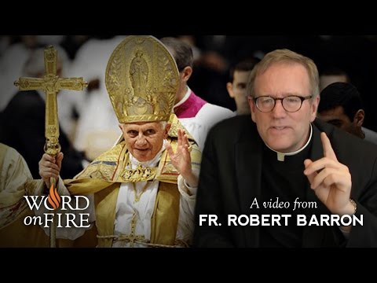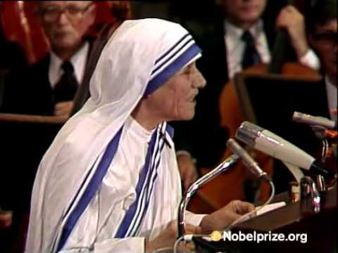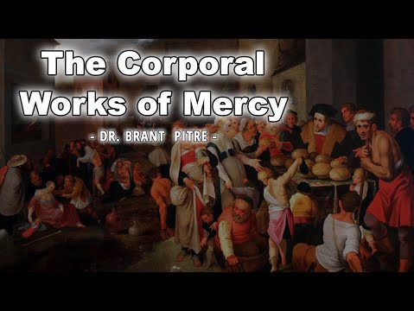
11. Mother Teresa’s Nobel  Acceptance Speech  The twentieth centuries’ most famous Catholic saint who gave her life to serving the poorest of the  poor fearlessly exposes the cultural decadence and appalling abortion industry in the West. Mother Teresa offers a great model of speaking truth to power. | https://youtu.be/I36Nistc9wE
12. The Corporal Works of Mercy  Dr. Brad Pitre examines the biblical meaning of Matthew 25. He covers each of the corporal acts of mercy and places them in a context of everyday Catholic life. | https://youtu.be/CBpwviO2e5g
13. Why Doesn’t the Church Give  Away Her Riches?  In this brief video, Bishop Robert Barron responds to a common question that many ask. He puts the question in perspective by giving a reasonable answer. | https://youtu.be/EOaJTObCsLs

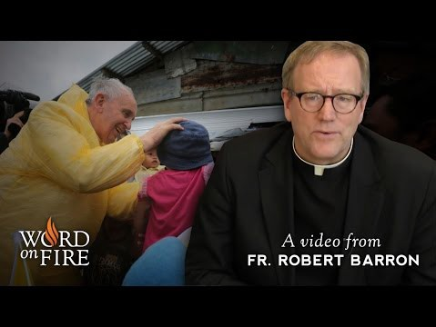14. Pope Francis and Catholic
Social Teachings
In this video Pope Francis’ pontificate is examined in the light of his commitment and preaching related to catholic Social teachings. Bishop Barron gives clarity to the meaning of Pope Francis’ teaching on the Throw Away Culture as it stands in the long tradition of Catholic Social thought.
https://youtu.be/iGCcDH9Mp4w

