Chapter 1, Introduction, p. 3.
Collating Examples. As you read the section, create a chart like this to help you list positive and negative examples of individualism and consumerism. Use examples from the text and from your own experience.
 | Positive Examples | Negative Examples
Individualism
Consumerism

Chapter 1, Section 1, p. 8.
Sequencing Events. As you read this section, create a chart like this one to help you label the following events in chronological order for founding of the Church: Sinai covenant, New Covenant, covenant with Abraham, Babylonian Exile, Protoevangelium, Prophets, and monarchy. Write brief notes to explain each event’s significance.

Events | Notes

Chapter 1, Section 2, p. 13.
Identifying Images of the Church. Use a concept web like the one below to record several images of the Church mentioned in this section (including the separate feature, “More Biblical Images of the Church” on page 17). Add circles as necessary.

Kingdom of God

Images of the Church

Chapter 1, Section 3, p. 20.
Reading Extension. When St. Peter’s speech at Pentecost is referenced in this section (page 22), read the entire speech in the Acts of the Apostles (Acts 2: 14-41). Answer the following questions.

- What were Peter and the other Apostles accused of? (vs. 15)
- Which prophet does he quote? (vss. 17-21)
- How was Jesus different from King David? (vss. 29-35)
- What did Peter say those who heard him must do? (vs. 38)

Chapter 1, Section 4, p. 25.
Recognize Main Ideas. Copy a design like the one here that depicts the Church being built on the foundation of the Apostles. In the upper floors, add decisions made by the Apostles and their successors (the bishops) that helped form the Church. Add as many “steps” as needed.

Instituted New Rituals and Worship

Apostolic Foundation

Chapter 2, Introduction, p. 47.
Recognize Main Ideas. Write words or draw symbols like the ones below to help you remember four ways the Church’s unity is guaranteed. Some examples are provided.

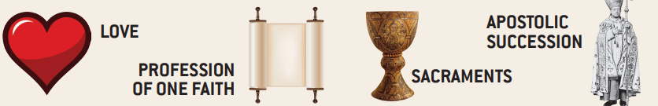

Chapter 2, Section 1, p. 50.
Scripture Reading. Read the entire Scripture passages on love and unity introduced in this section and listed in the following table. Create and summarize the main idea of each passage in the second column.
Scripture Passage | Main Idea
1 John 4: 13-21

Mark 12: 28-34
John 10: 22-44
Colossians 1: 15-20
Matthew 18: 15-20

Chapter 2, Section 2, p. 54.
Recognize Sequence. Create a timeline, like the one below, of the main occurrences of apostasy, heresy, schism, and martyrdom mentioned in this section. Also include on the timeline the Church Councils that responded to these occurrences. Look for dates and other clues for sequence in the text.

249
Decius Decree
2010
Baghdad Massacre

Chapter 2, Section 3, p. 67.
Understand Effects. Create and fill in a chart like the one below explaining how the liturgy highlights effects of the Church’s unity.
Parts of the Liturgy Where the Church’s Unity is Highlighted

Eucharistic Prayer | Lord’s Prayer | Communion

Chapter 2, Section 4, p. 74.
Organizing the Main Idea. Create drawings like the one below to represent each Church ministry. Write one or two words below each drawing to remind you how this ministry is (1) connected to the Apostles and (2) helps to preserve and share the faith today.
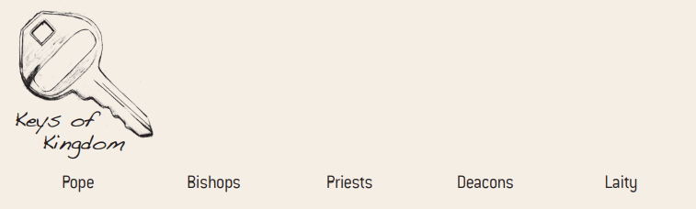

Chapter 3, Introduction, p. 97.
Analyze Information. Three ways to live a life of holiness are listed in this chart. Recreate it for yourself, then write an example of how Thomas Merton lived each one of these ways. Also list examples of how you are or will live out each way of holiness in your own life.

Ways to be Holy | Thomas Merton | You
Prayer
Good works
Living a Christian vocation

Chapter 3, Section 1, p. 101.
Summarize Information. As you read the section, write one-sentence summaries that trace the Church’s understanding of holiness and answer the following questions.

How is God holy?
How was holiness understood in the Old Testament?
What does the Son of God incarnate teach about holiness?

Chapter 3, Section 2, p. 107.
Recognize Connections. As you read through the section, march the term in the right column with the vocation most associated with it from the left column. In your notebook, write one sentence for each vocation that includes the name of the vocation and the corresponding term.

evangelical counsels
dedicated career focus
governance
service
preaching
domestic church

Bishop
Priest
Deacon
Sister or brother
Husband or Wife
Single Person

Chapter 3, Section 3, p. 119.
Draw Conclusions. As you read the stories of the three models of holiness profiled in this section (pages 121-124) create a table like the one below to help you list examples of how they exemplify the following characteristics of holiness.

 | Prayer | Self-Denial | Living the Virtues
St. Francis de Sales
St. Thérèse of Lisieux
Bl. Pier Gorgio Frassati

Chapter 3, Section 4, p. 127.
Synthesize Information. Several titles for Mary help to reveal her holiness. Create a web like the one here to name and define the titles. Add circles as needed.

MARY

Chapter 4, Introduction, p. 147.
Apply Information. While reading this section, define Catholic with a capital “C” and catholic with a lowercase “c.”

Catholic:

catholic:

Chapter 4, Section 1, p. 149.
Recognize Concepts. As you read this section, create a concept web like the one here and use it to make a list of words that describes the Church’s catholicity.

catholic

Chapter 4, Section 2, p. 154.
Applying Information. As you read the section, name two parishes in your diocese that contrast for each difference. Fill out a chart like this one.

Differences | Parish 1 | Parish 2
Language/Ethnicity
Socioeconomic
Education levels
Theological perspectives
Other

Chapter 4, Section 3, p. 159.
Compare and Contrast. Create a Venn diagram like the one here to show how other Christians and non-Christians share some things in common with the Catholic Church. Some things in common are: belief in one God, the Bible, Baptism, family of Abraham, moral judgement. Also include other commonalities not mentioned in the section.

Catholic Church

Other Non-Christians

Other Christians
Jews

Chapter 4, Section 4, p. 162.
Identifying Main Ideas. As you read, create an outline like the one started for you below to record the main sub-points for how chapters 1 to 15 of the Acts of the Apostles recorded the Church’s missionary mandate.

- How did the Church expand in her first century?
  - Pentecost

  - Preaching to the Samaritans

Chapter 5, Introduction, p. 183.
Key Words. Write three sentences describing how the Church is apostolic. Make sure that all of the following words are used at least once.
Apostles
Faithful
Successors
Foundation
Capstone
Holy Spirit

Chapter 5, Section 1, p. 185.
Recall and Categorize. As you read the following section, make a list of four important stages of God’s Revelation. On a second list, name four significant memories from your own life.

Four Stages of God’s Revelation | Four Significant Personal Memories

Chapter 5, Section 2, p. 190.
Identifying Supporting Details. As you read this section, create a concept web like one of the following to record details about the meaning of Sacred Scripture and Sacred Tradition. Add more circles as needed.

continuity with the Apostles
interpreted by the Magisterium
Sacred Tradition
inspired by the Holy Spirit
inerrant
Sacred Scripture
inspired by the Holy Spirit
inerrant
Sacred Scripture

Chapter 5, Section 3, p. 194.
Summarize Information. Create a chart like the one below. As you read this section, fill in a definition of each element of Church teaching and at least one example for each.
Teaching | Definition | Examples(s)
Creed
Dogma
Doctrine
Canon Law

Chapter 5, Section 4, p. 203.
Supporting Details. Create a flow chart like the one below to highlight the three main tasks of the pope and bishops. Use additional panels to name and summarize three levels the bishops teach on within the Church.

TASKS OF THE POPE AND BISHOPS

To Teach

Chapter 6, Introduction, p. 221.
Summarize and Expand. As you read the following section, create a chart like this one to help you list examples of the ways Catholics in the following categories “are leaven for the world”; that us, examples to others of holiness and social commitment. In each column add an additional example not found in the section.
Saints | Catholics in the News | Teenagers

Chapter 6, Section 1, p. 225.
Synthesize Information. Copy this table listing primary source quotations or references included in this section. Complete the missing categories. Rephrase a summary for each quotation in your own words.
Reference | Quotation | Summary
Mk 1: 15 | “This is the time of fulfillment. The kingdom of God is at hand.” | The Kingdom is present oriented as well as future oriented.
Mk 10: 45
 | “It’s better to light one candle than to curse the darkness.”
CCC, 765
 | The Church is “the initial budding forth” of God’s Kingdom.

Chapter 6, Section 2, p. 230.
Definitions. Copy the chart below and write definitions for the following terms based on your reading of the text. Then add an example of how the Church puts into practice each of these definitions today.
Term | Definition | Example
Evangelization

New Evangelization

Chapter 6, Section 3, p. 236.
Summarize and Define. Draw a table like the one show here. As you read the section, use short phrases to summarize and define some principles of modern Catholic social teaching, drawn from the body of Church teaching since People Leo XIII promulgated Rerum Novarum in 1891. In the third column, design a logo or a symbol to help you remember each principle.

Principles of Catholic Social Teaching | Summary and Definition | Your Own Logo or Symbol
The Dignity of the Human  Person | All life is sacred; right to be born is central; “seamless garment”
The Common Good

Preferential Option and Love for the Poor and Vulnerable

Economic Justice

Subsidiarity

The Family is the Model of Church

