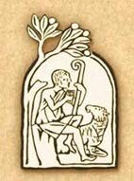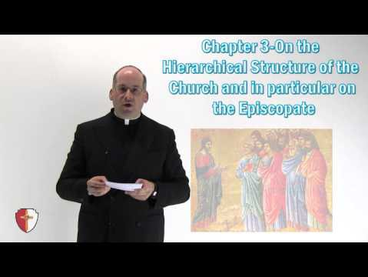

IV. Jesus Christ’s Mission Continues in the Church
Jesus and the Church: One, Holy, Catholic, Apostolic
Video/Document Title and  Description | URL Video/Document Link
1. CCC Article 9: “I Believe in the Holy Catholic Church.”  This is the sections of the Catechism that provides the doctrinal foundation for the Church. These sections shed light on the videos below. | https://www.vatican.va/archive/ccc_css/archive/catechism/p123a9p1.htm
2. Lumen Gentium  This video gives an overview of the Dogmatic Constitution on the Church from the Second Vatican Council. An  introduction to Lumen Gentium  is an appropriate starting point for any course on the Church. | https://youtu.be/2JTEFRtB0Z4
3. Pentecost in 2 Minutes  This video gives a brief overview of the meaning of Pentecost and the relationship between the Holy Spirit and  the Church. | https://youtu.be/J5tr4pqWIo4
4. The Holy Spirit in the  Life of the Church | https://youtu.be/QH3tF7abpts

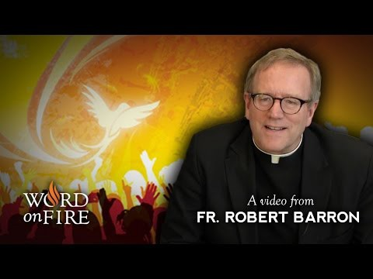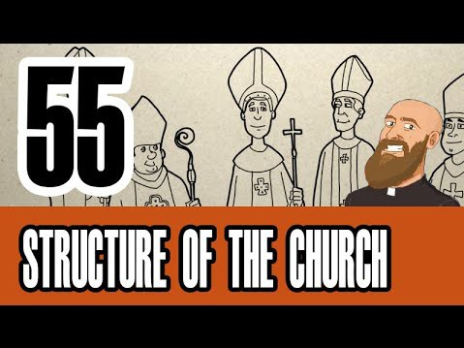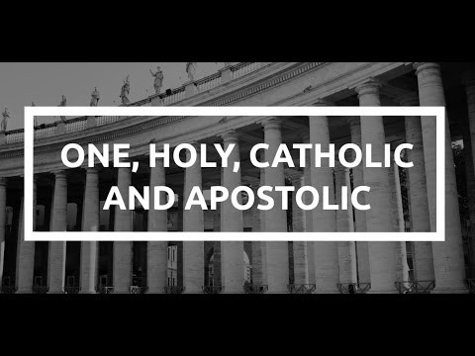
In this video Bishop Robert
Barron lays out the relationship between the biblical representations of the Holy Spirit and how the Holy Spirit generates and animates the
life of the Church.
5. St. Peter, The Rock  Jesus founded the. This video discusses Peter as the rock of the Church. | https://youtu.be/RSgKTGyrREA
6. Structure of the Church  This video covers the apostolic structure of the Church’s leadership and how they serve the universal church through apostolic and papal succession. | https://youtu.be/cHEzyxxIktY
7. One, Holy, Catholic, Apostolic  This video gives an overview  of the four marks of the Church in Scripture and Tradition. It examines what these marks mean to us as members of the Church. | https://youtu.be/78ZZ4FGbAH0
8. Introduction to the  Models of the Church | https://youtu.be/lpOVsFtZ1hM

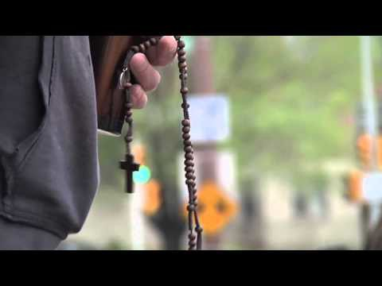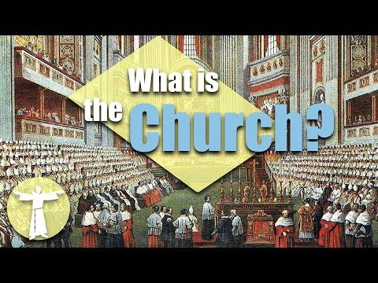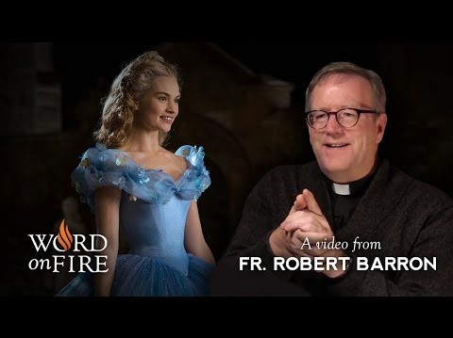
This video gives a visual
introduction to the beauty and mystery in the models of the Church.
9. Five Models of the  Church  This video gives a more comprehensive overview of the five models of the Church that Cardinal Avery Dulles taught. | https://youtu.be/VauojyTyA6o
10. The Church as Bride of  Christ in “Cinderella” Bishop Robert Barron examines the original Christian meaning of  Cinderella story. He points out the allegorical sense in the story and how Catholics view the Church as Bride of Christ. | https://youtu.be/qwCl_xcF4nA
11. The Church in Heaven: Saints  This video briefly covers the  process for canonization. It discusses the meaning of the sainthood and communion of saints as well. | https://youtu.be/lUGRdpRJWYA

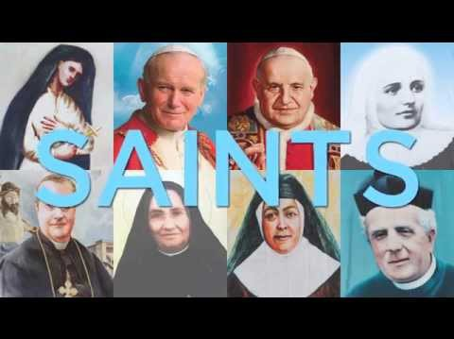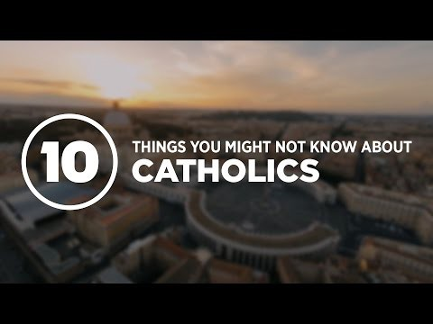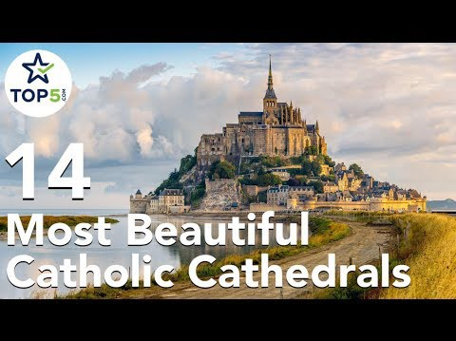
12. The Church in the  World: 10 Facts  This video gives ten interesting facts about the Church of  which most people are not aware. It clarifies many modern misconceptions about the Church along the way. | https://youtu.be/oADJy5ZiQdU
13. The Church Universal: Fourteen Amazing  Cathedrals Around the  World.  This video highlights some of the architectural heritage of the Catholic Church. This video also reveals the Church as a worldwide body of believers. | https://youtu.be/OhnydLHX_u4

