

“I’m not racist! In fact, I try to be color blind. I don’t even notice the color of my

students. I try to look at them as being all the same.” (Statement made by a Catholic

high school administrator and teacher).

Tragically, this mentality has contributed to the academic failure of many students who speak a language other than English in the home (ELL students) and students of color. According to Dr. Patnode’s text, ¿Me Puede Enseñar?: A Guide to Educating Hispanic/Latino Students in Catholic High Schools, the ELL population of students is the fastest growing population in the United States representing nearly one child in every four school age children (Corpora, 2016; Dees, Lichon, & Roach, 2017; Elliott & Parks,
2018). “It is safe to say that all teachers will, at some point in their careers, have at least

one ELL under their tutelage” (Nguyen, 2012, p. 129).

Many Spanish speaking ELL students are failing in American schools. Researchers acknowledge that the national dropout rates for Hispanic/Latino students are still among the highest measured totaling 12.7 percent for Hispanics/Latinos compared to
4.3 percent for whites and 7.3 percent for African-Americans (Corry, Dardick, & Stella,

dropout rate climbs to a national rate of close to 20 percent (Civic Enterprises, 2019).

The reasons for the high level of Hispanic/Latino ELL high school dropouts are varied and complex. Researchers have identified numerous barriers to graduation for Hispanic/Latino ELL students. Some of these barriers include low socio-economic
status, the difficulty acquiring academic language, differences in cultural understanding of education including parental involvement and student-teacher relations, deficit
ideologies, social and political hierarchies, as well as spiritual practices .

Among the increasing number of Hispanic/Latino Catholics in the United States, only 3

percent attend a Catholic school. As a result, Catholic schools have directed marketing efforts toward increasing the enrollment of Hispanic/Latino students. This is both an economic practicality and moral practice for Catholic schools.
Accepting Hispanic/Latino students (as well as students of color, students with diagnosed learning challenges, and students from low socio-economic backgrounds) requires that Catholic schools be able to meet the needs of these students. This can be a challenge for Catholic educators who may not be trained in best practices among diverse learners. While the number of ELLs is increasing dramatically, the number of Catholic teachers and leaders prepared to teach and care for them lags behind.

success with graduation rates and college readiness for all students, including minority

students. Hispanic/Latino students who attend Catholic schools are more likely to graduate from high school and college than their peers in public schools (Contreras,
2016; Lichon & Dees, 2017; Notre Dame Task Force, 2009). However, researchers and practitioners wonder why this is the case. I also wanted to better understand what Catholic high schools were doing to achieve success with their Hispanic/Latino ELL students. Through interviews, focus groups, and in-class observations, I sought to find answers to the following question:
• What practices at a high performing, culturally diverse Catholic school do

educators perceive are most essential in helping the Hispanic/Latino ELL student feel validated and graduate on time?
Secondary questions included the following:

• What academic practices of this school do educators perceive are most beneficial in helping students graduate on time?
• What cultural practices of this school do educators perceive are most beneficial

in helping students graduate on time?

• What spiritual practices of this school do educators perceive are most beneficial in helping students graduate on time?

practices of this school?

The information gathered from the teachers, staff, and administrators can benefit all who work in the field of education. These passionate educators shared best practices that go beyond the realm of platitudes and theory. The effective support structures and
relationship-building efforts that these experts shared are worth broadcasting to all who work with Hispanic/Latino students. Most important, these educators and administrators identified the unifying factor that leads to their continued success. That unifying factor is, interestingly, the foundation of Catholic education—and it is time for
it to make a resurgence!

1. Be aware of differences

To be “color blind” toward people is to be “culturally blind.” It is imperative that teachers and administrators learn about the cultures from which their students come. A Hispanic/Latino student who speaks Spanish in the home brings a different world view to education than a student who comes from an English-speaking home. Likewise, an African student has a treasury of cultural experiences that differs from the rich cultural experiences of an African
American student. Understanding, respecting, and affirming cultural differences

of teachers being familiar with the culture of the students within the classroom

(Hill & Torres, 2010; López, 2016; Zimmerman, 2008). One researcher suggested that teachers who use instruction that considers students’ culture are an asset that can reduce educational disparities (López, 2016).” See Chapter 3 for more information on this topic.

2. Focus on the whole student.

Historically, Catholic schools have achieved a higher level of academic success with Hispanic/Latino students than public schools. The reason is clear. Catholic schools focus on the whole student. One teacher noted, “I think one of the key successes, you know, we talk a lot about cura personalis at our school . . . care for the whole person. And part of it is we truly feel that students, if they don't feel that they are loved and safe, and if they don't have relationship[s], then they won't be as likely to succeed.” Cura personalis [care for the whole person] is consistent with Catholic teaching which states, “The school must beginfrom the principle that its educational programme is intentionally directed to the growth of the whole person” (Garrone, 1977, para. 29).
Participants [in the research] also identified secondary practices that assist in caring for the whole person. Those secondary themes fell under the categories of

subcategories that uphold practical support structures and relationship building

were identified as academic supports, cultural practices, spiritual supports, student validation, and college and career supports. The following figure illustrates the overarching theme and its supports. (Patnode, 2020). See Chapter 6 for more information.
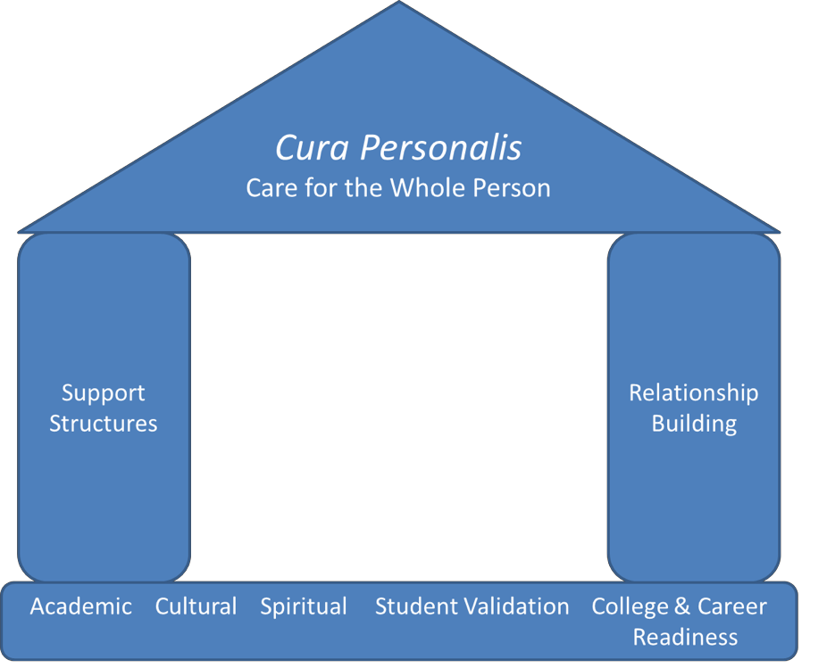

Figure. Emerging from focus groups and interviews was the overarching theme of cura peronalis, care for the whole person. This practice was identified as the main reason for the 100% success rate of students graduating on-time from St. Benedict Catholic High School (This name is a pseudonym). Cura personalis is upheld by the secondary themes of: practical support structures and relationship building. In addition, the subcategories of academic, cultural, spiritual, and college and career practices along with student validation uphold the support structures and relationship practices, which in turn bolster the care for the whole person. (Patnode, 2020).

3. Provide students with designated work time and tutoring during the school day.

centered (collectivist framework) have family and community responsibilities

outside of school. These responsibilities may prevent them from completing school work outside of school hours.
The collectivist framework of values explains that one significant cultural reason for dropping out of high school is the desire to get a job to help contribute to one’s family. This sense of family obligation is consistent with collectivist values common among Hispanic/Latino families. An individualistic framework, for which the United States educational system is known, includes “autonomy, assertiveness, freedom of choice, self-fulfillment, and a sense of personal uniqueness” (Arevalo, So, & McNaughton-Cassill, 2016, p. 4). In contrast, collectivism includes an interdependence of members within the group through the functioning of social roles, duties, and obligations. These collectivist values, common within the Hispanic/Latino culture, may include a Latino student’s responsibilities such as taking care of siblings and preparing meals. These responsibilities may detract from school related responsibilities/activities. It is
this collectivist perspective, in which the needs of the family supersede the needs of the individual, that partially explain the reason why students drop out of school in an effort to help support the family through a job or other means.

disparity in access to technology and internet that many students in low socio-

economic communities encounter. See Chapter 3 for more information.

4. Employ cultural practices that positively influence students.

Certain cultural practices can result in academic gains. These practices are outlined in Chapter 6 and include student validation practices, signage around the school, specialized personnel roles, discipline practices, and clubs, classes, and activities. Small but significant practices such as having Spanish-speaking personnel who can communicate with Spanish-speaking family members, acknowledging (or even celebrating) a significant cultural holiday (such as Our Lady of Guadalupe), utilizing a positive, individualized discipline approach that focuses on making gains, and offering culturally relevant clubs, classes, events, and/or activities have been researched and are recognized as helping Hispanic/Latino ELL students.
5. Consider academic support practices that positively influence students.

A focus on the whole student must necessarily consider academic practices that help a student attain success. Significant academic practices are outlined in great detail in Patnode’s text. Unfortunately, teachers might consider Hispanic/Latino students who do not complete work on time to be lazy and/or irresponsible. Although this may be the case with a few students, more likely, the student is not

Hispanic/Latino students have undiagnosed learning challenges that have never

been addressed or helped. Other students simply need more guidance or tutoring, while still others need time during the school day to complete homework due to outside responsibilities (as mentioned earlier).
Academic supports are established practices that help students attain on-time high school graduation and acceptance to college or military. Practices discussed in greater detail in Chapter 6 of Patnode’s text include scheduled, day-time opportunities for students to receive help with academic work, tutoring programs, standards-based grading, professional development and/or coaching of faculty, and the need for high academic standards with supports (this includes an extremely well-organized, school-driven, college-bound program).
6. Do the faith practices of s school influence academic achievement?

According to research, the answer is “yes”. Researchers and practitioners notice improved academic outcomes among students who attend faith-based institutions. One Catholic high school teacher suggested that the spiritual practices of their Catholic high school were an integral part of caring for the whole person. This teacher suggested that the importance of the spiritual culture permeates the mission of the faculty and staff. While referencing a picture of a

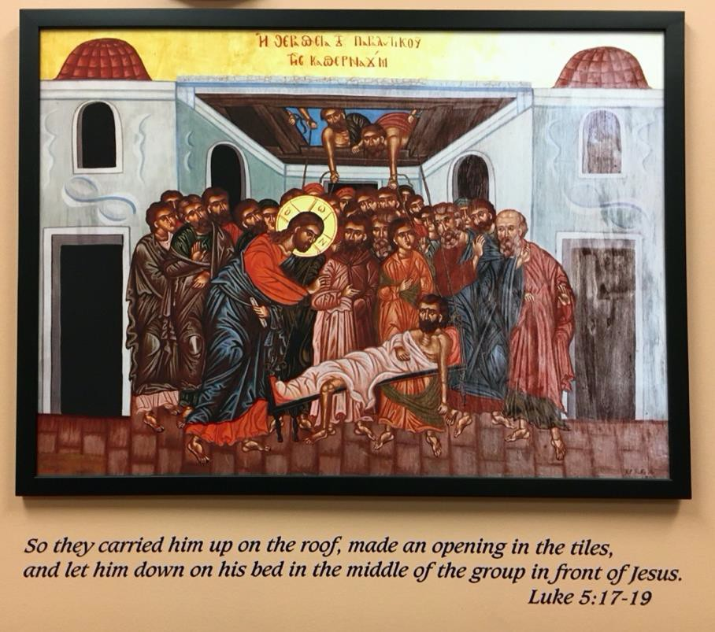

explained,

I like to see that picture right there, of the paralytic being brought in (Luke

5). And that's our metaphor for our school. …That image with the disciples is this, the people tried to get to Jesus but couldn't because they were blocked. So, they put a hole in the roof so they could get the person to Jesus. We also try to create different and unique opportunities. When the pathway to success is blocked for our students, we create new and unique opportunities for them to succeed.
Other practices that prove important include daily prayer, a sincere love for one

another, service, and shared values. See Chapter 6 for a detailed description of each practice.

Figure. Photograph of the picture of the biblical story of the paralytic being lowered to Jesus through the hole in the roof. This picture hangs in a conference room at St. Benedict Catholic High School and serves as an important reminder to faculty and staff to seek ways to help students achieve success despite challenges that block the traditional pathways to success.

7. Build relationships.

Relationships matter and relationship building must be a purposeful action in caring for the whole person. During the research, teachers noted a general belief that “education comes through relationships” and building community plays an important role in student development. One teacher explained that “relationship building with all students is a key part of our jobs.” A Director of Campus Ministry observed that “genuinely thinking about the student as a whole person and … connect[ing] with them and, and build[ing] those relationships—fosters
… that whole person development.”

One consideration for Catholic school leaders is to review faculty and staff job descriptions and consider adding relationship building with co-workers,
students, and families as an annual performance measure. Regularly, the

principal of one of the schools in this study reminded faculty and staff of this objective, and routinely was the practice of it reviewed. Moreover, because this is a priority that is intentionally practiced, school leadership carefully considers the number of faculty, staff, and volunteers that it employs to keep teacher expectations realistic and doable. This Catholic high school has creatively sought

ways to increase the number of adults working with students (either as employees or volunteers) through partnerships with Catholic Charities, local corporations, and diocesan parishes. Other Catholic educators could also consider these unique partnership opportunities to improve teacher-student ratios.
In addition, Catholic education may benefit from an examination of the intentional student validation practices within schools. See Chapter 6 for more
details on this topic.

The discovery of the importance of focusing on the whole person (cura personalis) is a

reminder to Catholic educators to keep the larger goal before their eyes. It can be easy to get lost in the details of programs, processes, and professional development. However, keeping the whole person in mind, while having support structures and relationship building in place, appears to be a critical factor in helping Hispanic/Latino ELL students achieve success. Although qualitative research seeks understanding over generalizability, all Catholic educators are called to educate the whole child . To achieve this mandate, Catholic administrators should consider reviewing this overarching goal while identifying the practical structures and relationship building practices that they have in place to achieve the goal.

Overarching Theme

Cura personalis (Care for the Whole Person)

Secondary Themes

• Practical Support Structures

• Relationship Building

Subcategories of Support

Academic | Cultural | Spiritual | Student  Validation | College and Career Readiness
• Structured Time During School Day  • Tutoring  Program  • Standards- based Grading  • Professional Developme nt and/or Coaching of | • Validation of the Hispanic/La tino Culture  • Spanish Language Use  • Clubs, Classes, and Activities  • Support Personnel Within | • The Daily  Examen  • Love for One Another  • Service  • Shared  Values | • Approach to Discipline  • Student  Recognition | • Corporate Work Study Program  • School- driven College Process

Faculty  • High Academic Standards with Supports | School

1. Examine one’s school plan for helping the whole student.
Review church documents including the Sacred  Congregation for Catholic Education’s (1977) The Catholic School and The Cardinal Newman Society’s Catholic Education Report (2015) The Call to Teach: Expectations for the Catholic Educator in Magisterial Teaching. | Comments:
Identify all of the support structures available for  Hispanic/Latino students at one’s school and compare them to those identified at St. Benedict Catholic High School. Consider which supports are missing at one’s school and how they could be added. | Comments:
Consider the mission and vision statement of one’s  school to determine if the whole student approach is an identified goal within the school. | Comments:
2. Study one’s academic, cultural, spiritual, validation, and college readiness
practices compared to those of St. Benedict Catholic High School.
Prepare a list of the support practices of one’s school.  Compare that list to the supports offered at St. Benedict  Catholic High School. | Comments:
Identify when the support practices occur at one’s school. Consider ways to offer all supports during the school day. St. Benedict’s has a longer school day and a longer calendar year. Consider if those practices would be of value to one’s own students. | Comments:
Determine if partnerships between one’s school and  local Catholic organizations, schools, businesses, and parishes would help provide resources and opportunities for one’s students. | Comments:

Prayerfully review one’s Catholic identity and how it is  lived out within the school through regular spiritual practices and service opportunities. Consider if more should be done to live out one’s Catholic identity. | Comments:
Review the college support provided to Hispanic/Latino students and parents at one’s school compared with the support offered at St. Benedict Catholic High School. Can one’s school provide more guidance to students  and parents, especially first-generation college students with non-English speaking parents? | Comments:
3. Review the relationship building practices within
one’s school.
Analyze one’s channels of communication between  faculty and staff; faculty and students; and faculty, staff, and families. Is the current communication structure strengthening relationships with faculty, staff, students, and families? What modes and frequency of communication are employed, and is this current plan working well for all parties? Does the school communicate with families in a language that families can understand and a mode that families utilize? | Comments:
Consider faculty and staff job descriptions and the role  that relationship building should play in performance measures. | Comments:
Review one’s discipline policy. Does the school strive to  validate students while implementing safe practices? How are corrections handled within one’s school compared with the practices of St. Benedict Catholic High School? Consider making necessary changes that include validation, re-training, goal setting, and | Comments:

recognition for making gains.
Examine one’s professional development program. Does  the school offer professional development? If so, how does the school determine what type of professional development is offered? Is the determining process collaborative? Is the professional development specifically related to the practical support challenges and relationship building issues faced at one’s school? What improvements can be made? | Comments:

