Handout 10-A First Cardinals
Name ______________________________________________ Date __________________

Directions: As you research the cardinals elevated in each of the last several consistories, make note on this map of any that you find to be the first cardinal from his home country. Note, either on the country or with an arrow pointing to it, the name of the country and of the cardinal, the year he was elevated to the cardinalate, and the pope who elevated him.

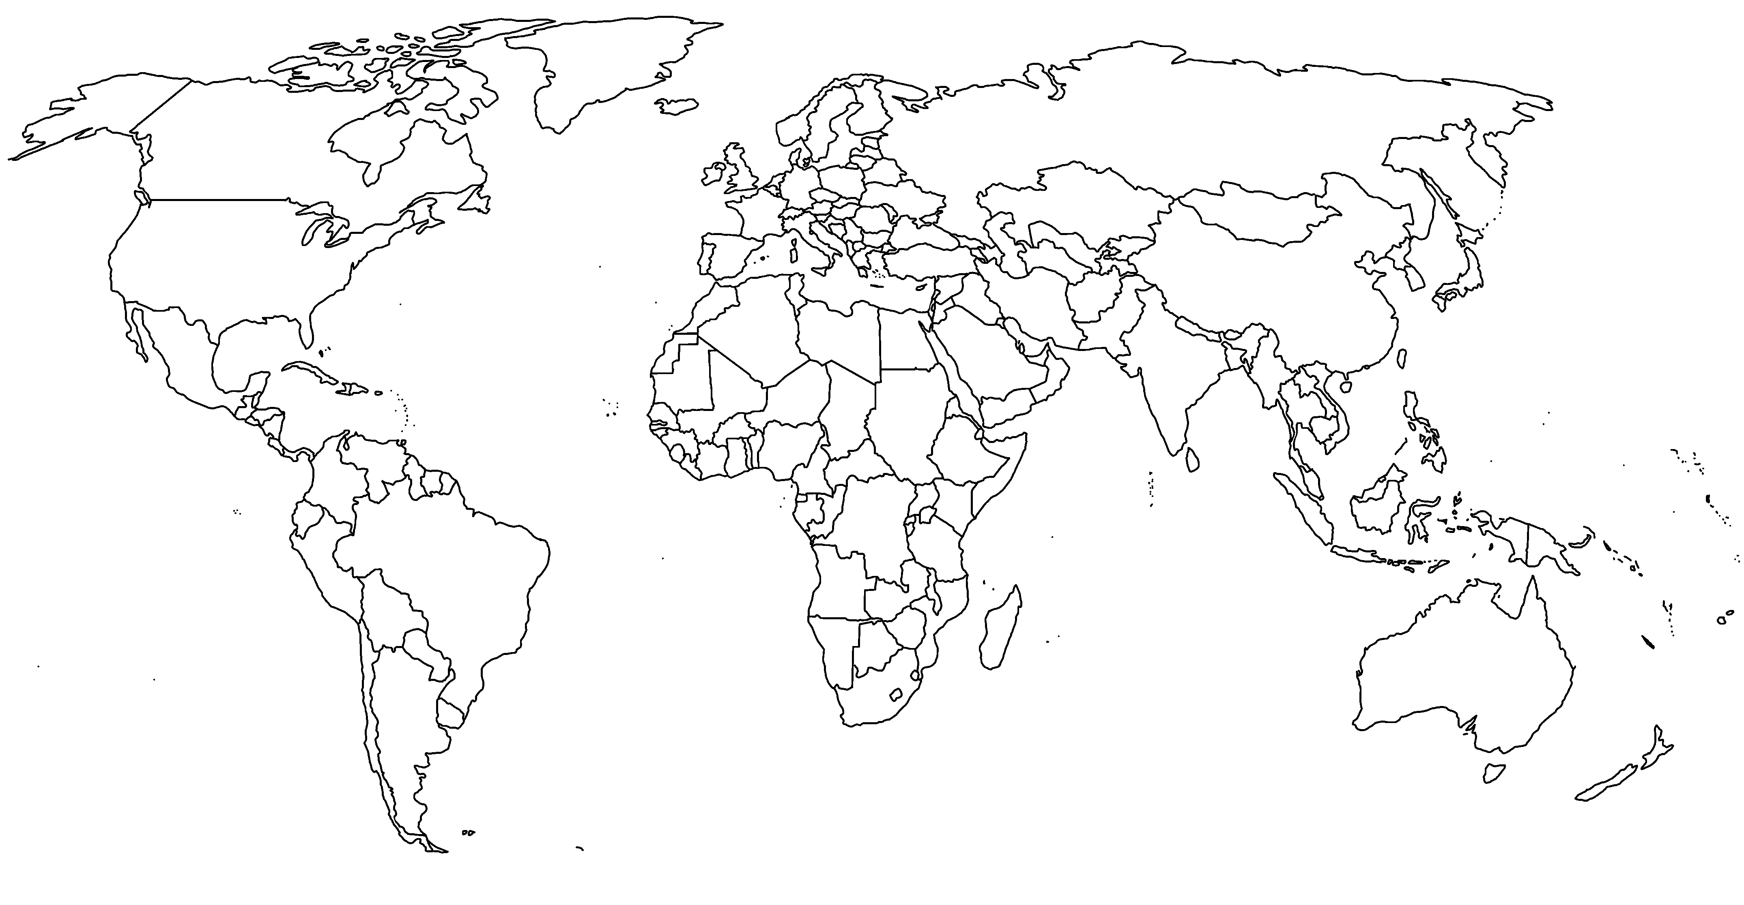

Name
Date

Handout 10-B

Videos of the 2013 Papal Transition

Directions: Locate and watch each of the following video clips on YouTube. For each, make notes in the table as indicated: a summary of the video, a sentence or two about what you believe to be most significant about it, and a single direct quote that struck you. Then, respond to the follow-up question in a few short paragraphs.

Video | Summary: What does this video show? | Commentary: What is most  striking or significant? | One notable direct quote
Announcement of Pope Benedict XVI’s Resignation (The Vatican – Archive) https://www.youtube.com/ watch?v=exSZqcQ3YZw
Pope Benedict XVI’s Historic Farewell (ABC News) https://www.youtube.com/ watch?v=JGBjL28DbnI
Benedict XVI’s Last Speech as Pope (RomeReports) https://www.youtube.com/ watch?v=H_pIgRQxis8
ABC News Coverage of Pope Francis’s election https://www.youtube.com/ watch?v=dnZaQ3STLaM
Pope Francis’s First 100
Days (RomeReports) https://www.youtube.com/ watch?v=rVat6KJ9Ag4
Pope Francis talks to the press about Pope Benedict XVI (RomeReports) https://www.youtube.com/ watch?v=ZDCPEjnKuco (begin at 5:12)

Follow-up question: Galatians 5:22–23 tells us that “the fruit of the Spirit is love, joy, peace, patience, kindness, generosity, faith- fulness, gentleness, and self-control.” The presence of these qualities bears witness to the ongoing work of the Holy Spirit in the person who is accordingly able to demonstrate them. Do you believe the Holy Spirit was at work in Pope Benedict XVI as he decided to resign, in the cardinals who elected Pope Francis, and in Pope Francis as he began his pontificate? Explain.

Handout 10-C

Already a Missionary

Directions: As you read the blog post “So You Want to Be a Missionary? Well Good. Because You Already Are,” consider your own life. Reflect on the questions below. In the final box, list at least five concrete actions that you can take starting immediately to participate in the mission of the Church.

Already Called – In what ways have you experienced God’s call in your life?

Already Preaching – What message is your life sending about
Christianity? What message do you want your life to send?
SO NOW WHAT?

SO NOW WHAT?

Already Sent – Who are some of the people in your life that you’re called to love?
Name ______________________________________________ Date __________________

Already Suffering – What difficulties do you endure for your
faith?
SO NOW WHAT?

SO NOW WHAT?

