Name Date

Handout 3-G

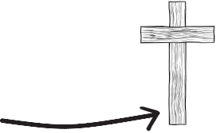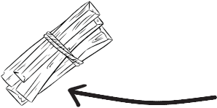Comparing the Sacrifice of
Isaac with the Sacrifice of Christ

Regarding the relationship between the Old Testament and the New Testament, St. Augustine said, “The
New Testament lies hidden in the Old Testament and the Old Testament is unveiled in the New.” These parallels can be observed in hundreds of biblical typologies that run within the pages of the Bible. The student text defines a typology thusly, “The study of prefigured patterns of divine activity. Typology in Scripture study involves reading the Old Testament in light of Christ crucified and risen.”
As an example, consider the story of the sacrifice of Isaac as a foreshadowing of the sacrifice of Christ on the Cross. Read Genesis 22 and fill in the corresponding passages regarding Christ’s sacrifice on the Cross.

Sacrifice of Isaac | Sacrifice of Christ
 | God offers his only Son.
 | Jesus rises from the dead on the third day.
 | Jesus carries the Cross.
 | Jesus is the Lamb of God.
 | God provides a male, Jesus, as a substitutionary sacrifice.
 | Jesus wears a crown of thorns.
 | Jesus is crucified on a hill outside of Jerusalem.

