LESSON 38

Name

Prophets Crossword Puzzle
Directions: Use the clues and the scripture passages listed on the next page to help you to complete the
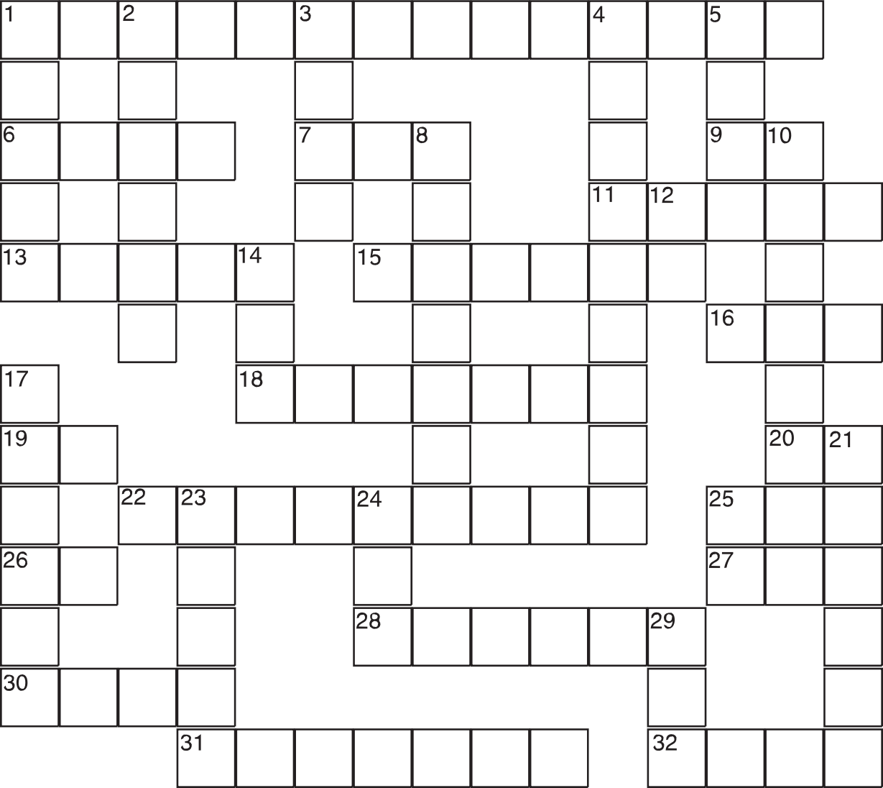crossword puzzle.

© 2005 Mark Quinn and Mark Scott 74

Lesson 38 continued

Across

1. Babylonian king who conquered Jerusalem
(Jer 52:4-11)
6. In Hosea 9:1, the harvest feast in honor of
Baal is called a “harlot’s ”
7. How the lamb who represents God’s suffer- ing servant arrives at the slaughter (Is 53:7)
9. Breakfast drink abbreviation
11. The minor prophet who compares his rela- tionship to his unfaithful wife with that of God and Israel
13. The minor prophet spoken of by Jeremiah in
Jeremiah 26:18
15. The major prophet who wrote about the suffering servant before, during, and after the exile
16. Abbreviation for the major prophet impris- oned in the mud at the bottom of a cistern
18. This minor prophet wrote about 460 B.C.E. and insisted that Elijah would return before the Day of the Lord
19. Latin abbreviation for “Anno Domini” (In the year of the Lord)
20. Latin abbreviation for “that is”
22. The minor prophet who predicted the Messiah’s entry into Jerusalem riding on an ass (same as 4 down)
25. Abbreviation for the minor prophet whose name in Hebrew means “my messenger”
26. What the Israelites are told to do in Babylon
(Is 48:20)
27. Feminine pronoun for the God who has mothering qualities (Is 49:15)
28. What Ezekiel had to eat before he could begin prophesying (Ez 3:1)
30. God will scatter the inhabitants of Jerusalem like chaff because they have trusted in this, says Jeremiah 13:25
31. The first prophet to receive his call outside of Israel, this major prophet described the four cherubim before the throne of God
32. The name for Jerusalem when it is consid- ered the dwelling place of the Lord

Down

1. The opening line of this minor prophet stated that his preaching would be about the fall of Nineveh
2. Jeremiah’s private scribe (Jer 36:8-10)
3. What the Lord God is to me, according to
Isiah 50:7
4. This minor prophet preached during the reign of King Josiah, two of his three chap- ters dealt with the Day of the Lord to come (also 22 across)
5. This minor prophet was a shepherd from Tekoa in Judah, but preached in the Northern Kingdom
8. What idolatr y brings, according to the prophets (see Jer 15:9)
10. This major prophet was told by the Lord to remain unmarried
12. An exclamation, as in Jeremiah 8:23
14. Noah’s son, supposed ancestor of the
Canaanites (Gen 9:22)
17. The first minor prophet after the exile ended; he encouraged the people who returned from Babylon to rebuild the Temple in Jerusalem
21. The number of minor prophets
23. If the Exodus was the central event of the Torah, what was the central event of the prophetic books of the Bible?
24. One of only two talking animals in the Bible
(Nm 22:21-35)
25. Abbreviation for manuscript
29. The former name of the shrine of Bethel
(Gen 28:19)

75 © 2005 Mark Quinn and Mark Scott

