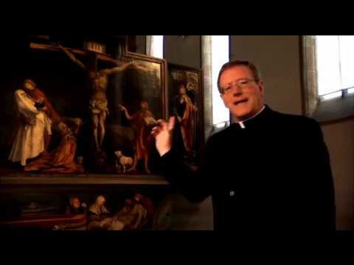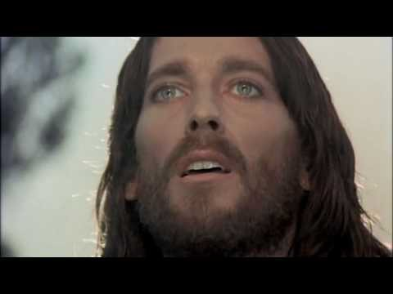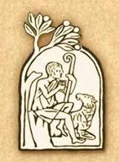
VI. Life in Jesus Christ
Your Life in Christ: Foundations in Catholic Morality
Video/Document Title and  Description | URL Video/Document Link
1. CCC Part III: Life in  Christ  This is the sections of the Catechism that provides the doctrinal foundation for morality. These sections shed light on the videos below. | http://www.scborromeo.org/ccc/p3.htm
2. The Sermon on the  Mount and Lord’s Prayer This is the excerpt from Jesus of Nazareth focuses on chapter  5 of Matthew, the Sermon on the Mount and the teaching of the Our Father. Jesus teaches how to live a moral life of perfection. | https://youtu.be/MDCbJ4vnMNg
3. The Beatitudes: The  Key to Joy  Bishop Robert Barron points to the four “P’s” as the world’s way to be happy: power, pleasure, prestige and possessions. He then compares those words to the happiness shared by Jesus gives us in the Beatitudes. He points out the importance of detachment from worldly things so that we are free to be  virtuous and more happy. | https://youtu.be/XHmTcxYHzy8
4. Happiness  Everyone wants to be happy. | https://youtu.be/liIdQ-m8Qtw

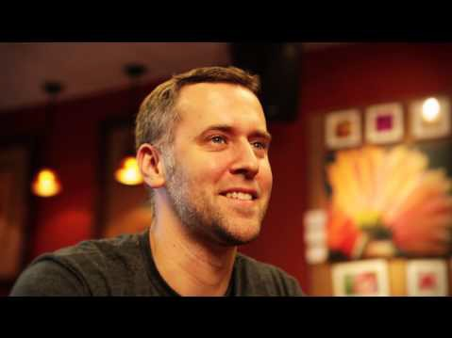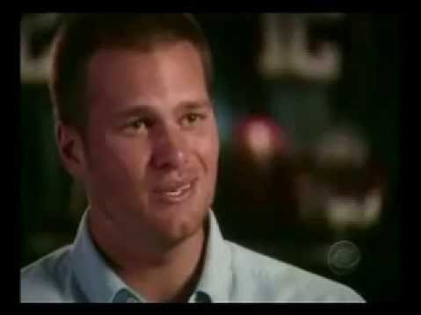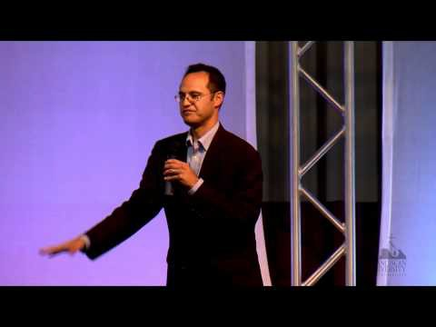
Every goal we have is ultimately
for happiness. This video connects our pursuit of happiness and our faith in God.
It points to Jesus’s goal for us. "I have told you these things so that my joy may be in you, and your joy may be complete!"
(John 15:11)
5. “There has to be More than This!” Tom Brady  In this video football quarterback  Tom Brady is interviewed on 60  Minutes and he talks about how everything the world says will make us happy is, in the end, not enough. There has to be more. | https://youtu.be/UHSfiKAtPzk
6. Values vs. Virtue  Dr. Ed Sri discusses the importance of developing virtue as a moral skill. He cites the  Catechism to define virtue as a  habitual disposition to do the good. He makes an important distinction between values and virtue. | https://youtu.be/HvkyIlyQDb0
7. Theological Virtues  This video is a thorough overview of the Catechism’s  section on the theological virtues. It points to the theological virtues as the foundation of Christian moral activity and how they are | https://youtu.be/kD6J7_NMTQc

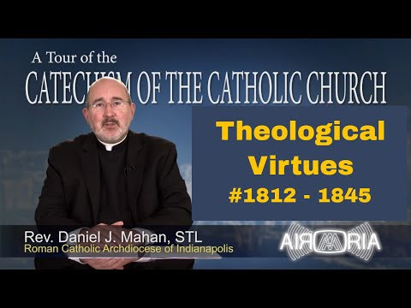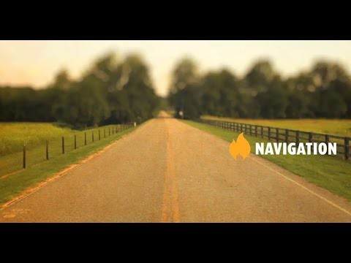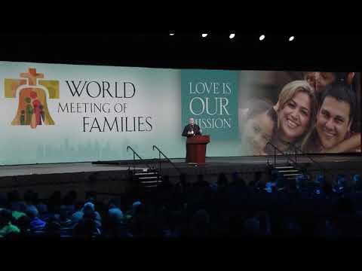
infused by God into our souls
through grace received in the sacraments.
8. Navigation: Developing a Moral Compass through Reason and Conscience  An exploration of the many paths we can choose to walk down in life and the importance of free will to choose the most important path. The video shows how reason and conscience act as our built in navigation system. Clever analogies are used. | https://youtu.be/axliNB8f4KQ
9. Freedom for  Excellence  In this video clip, Bishop Robert Barron clarifies the Catholic idea of freedom. He defines freedom as it relates and depends on detachment and virtue. | https://youtu.be/jc6NLaDJEpo
10. Morality of Human Acts: Object, Intent, Circumstances  In this video the morality of an | https://youtu.be/_fuCIJ2iEIU

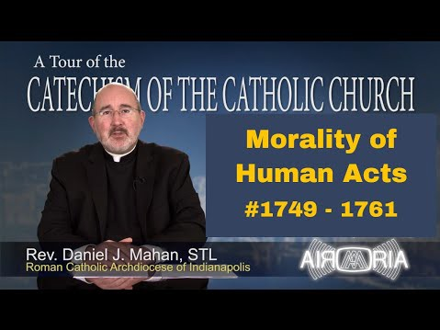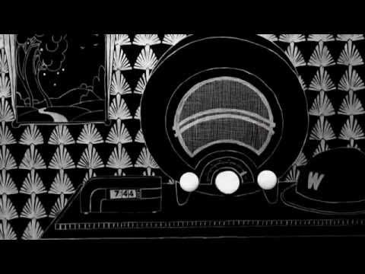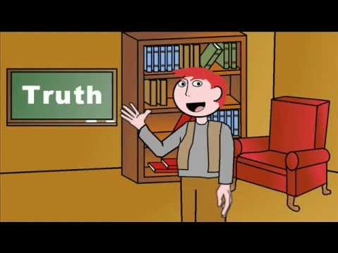
act is examined using the
Catechism’s three parts:
object, Intent and, circumstances. They are discussed as a way to determine the morality of an act as either good or bad.
11. C.S. Lewis Doodle: Right and Wrong  C.S. Lewis gives us a way to  discover the objective  meaning of right and wrong by appealing to a common standard. | https://youtu.be/QmHXYhpEDfM?list=PL9boiLqIabFgjeaTcx_LLsXrguKfeqLmn
12. Truth: Objective vs. Subjective  This video takes a  philosophical approach to exposing the problem of moral relativism. | https://youtu.be/yzzP9DeX_Jo?list=PL4EAFD5C1528C8F94
13. The Conversion of an Atheist Based on the Morality Argument  Atheist turned Catholic, Ivy  League blogger, Leah Libresco shares her journey from deontological ethics to virtue ethics and finally to | https://youtu.be/kThUVIe704I

entrance into the Catholic faith.

